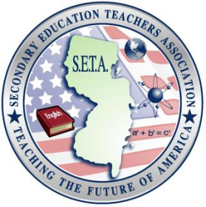

Secondary Education Teachers Association
Executive Board Meeting
Monday, October 4, 2010

Events for this Semester
- Panels & Guest Speakers
  - Any information on Lena’s panel or a definite date?
  - Career Services – resume/interview “workshop”

T-Shirts
- Results of survey

Mentoring
- Collaborating with other organizations

Taylor Mali
- We need to decide if we really want to do this
  - If so, we need to start working on details!
    - committee?
    - meet with co-sponsors

Adopt-A-Classroom
- TCHS!!
  - Ideas from Nancy Lee (librarian)
  - Set specific goals

