SPSS Version 11.0 For Use with the
Community Structure Approach

A Cadet’s Best Friend
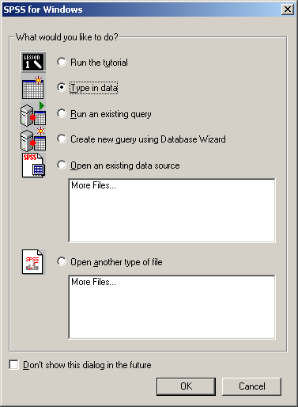

PART ONE: GETTING STARTED
1 Click on the Start Button
2. Go To Programs.
- Go to SPSS for Windows
- Click on SPSS version 11.0
- Choose the Type in Data option.
- Hit OK
- A Spreadsheet window should
Pop up on the screen.

PART TWO: ENTERING DATA

You will need to create two files using SPSS.
One is your City Level Set. It will contain all
Information pertinent to each newspaper’s
city. You will create twenty-one rows for
the data (one for each city). The second file
will be your Article Level Set. It will contain
all the prominence scores for every article you
code as well as the media vectors and the cities’
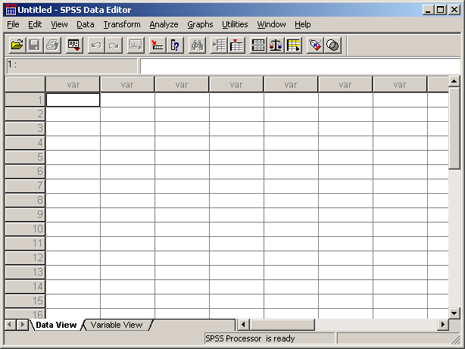
demographic information. It is easiest to begin
with the City Level Set.

CITY LEVEL SET

Start with a blank spreadsheet in SPSS.
You will notice above the first column is
a gray box with the word var in it. We are
going to define that box and several others
to match your data.
Click on the tab for the Variable View Sheet.
In the first box type “newspaper” (You are
limited to 8 characters) then hit enter.
Continue this process to define more variables.
Numbers and values will automatically appear
Across the screen, Leave them Alone!
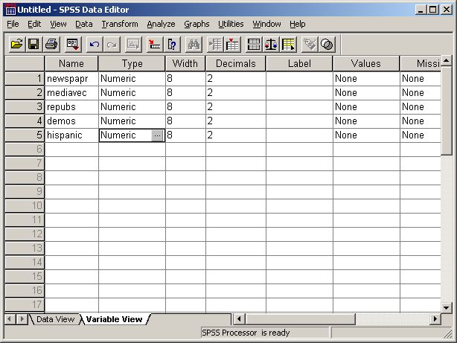
Your other variables should include the media
vector and abbreviations for your city
characteristics.
It is now important to create value labels.

Value Labels assign each city a number. This eliminates Confusion as the research progresses. To add value labels to the SPSS document you need to click on the first box beneath the Values column.

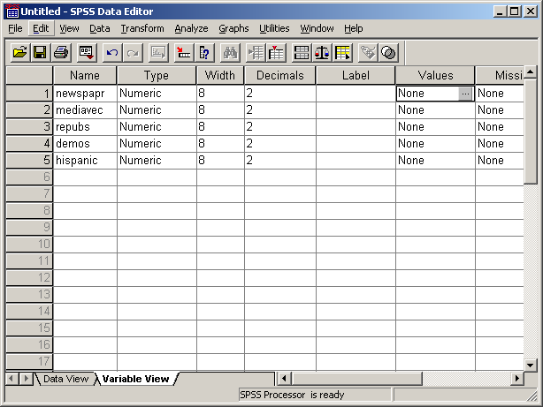

Now click on the little gray box with the three dots that appears within that box. The Value Labels window should appear.

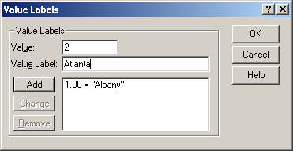

Type the number into Value and the City name into Value Label. Then click Add. List your cities in alphabetical order. When finished hit OK.
Return to the Data View Screen. You will notice that the columns of the Data View now
Match the variables defined in the Variable view. You are now ready to enter your data. It should look like this.

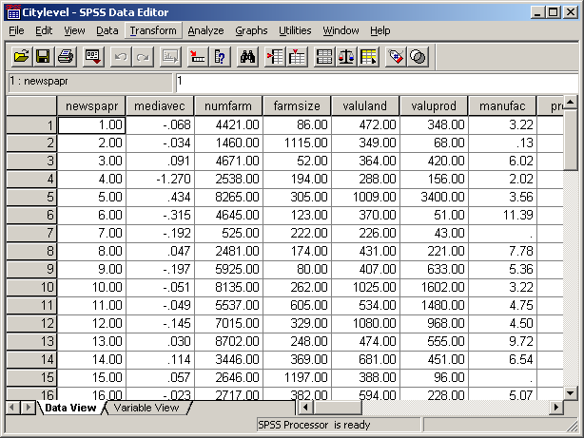

ARTICLE LEVEL SET

The next step is to create an Article Level Set where you combine the prominence scores, favorability rating, and city statistics for each article that you have coded.

- Under the file menu select New and then Data.
- You will need to define the columns using the variable view just as you did for the City Level Set.
- Assign a number (1-21) to each article that you have coded from each paper.
- Put the article in the first column.
- Put the newspaper number in the second column. (Be sure that the Value label for your Article Level set matches the Value Label for the Article Level set.)
- In the third column put the article’s Placement score.
- In the fourth column put the article’s Headline Score.
- In the fifth columns put the article’s Length score.
- In the sixth column put the article’s Photo score.
- In the seventh column out the article’s Directional score (Favorable, Unfavorable, Neutral)
- In the eighth column put the city’s media vector.
- In the remaining columns put the statistical data (% democrat, % Hispanic, etc.) that you have researched for that city. You can copy and paste that information from your City Level set.

You finished Article Level Set should look like this:

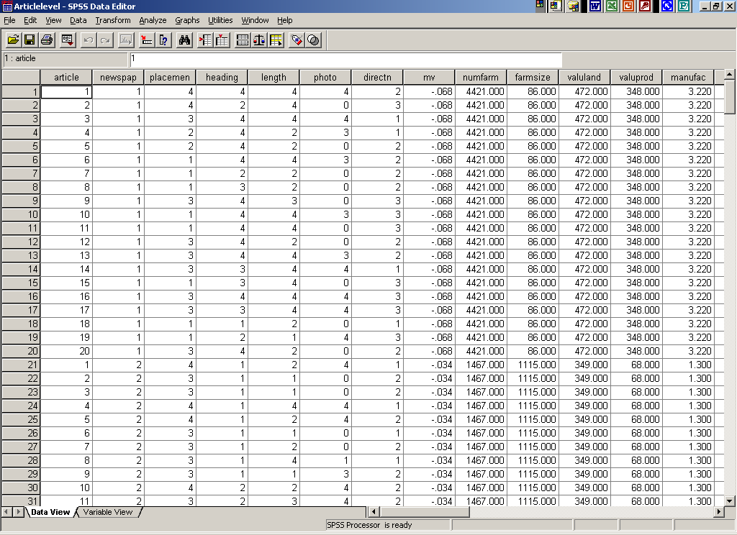

Good job. You have now successfully entered your data. It is now time to move onto Part three, analyzing the data with Pearson Correlations and Regressions.

PART THREE: ANALYZING DATA

PEARSON CORRELATION

The first data analysis will be done using Pearson Correlations.
- Open your City Level set.
- Go to the tool bar and click on Analyze
- Go to Correlate
- Click on Bivariate.
- On the Bivariate Correlations window select all your variables except newspaper city and move them to the right box by clicking on the gray arrow button.
- Make sure to check the Pearson box.
- Test of Significance should be One-tailed.
- Hit OK

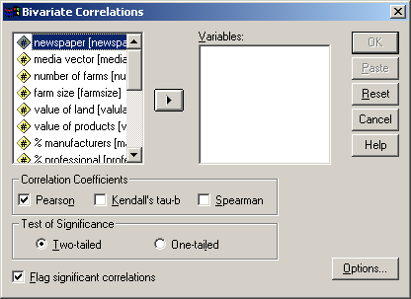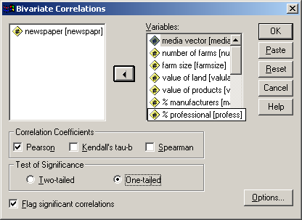
Before After

Your Output will look like this.

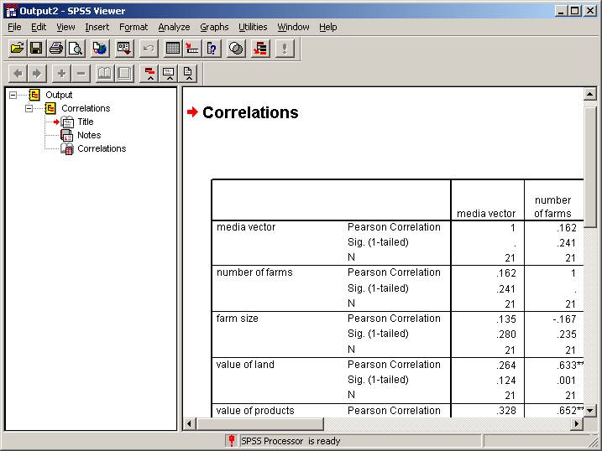
Sample output.

REGRESSION

For further analysis it is important to run regression.
- Click on Analyze in the tool bar
- Go to Regression
- Click on Linear.
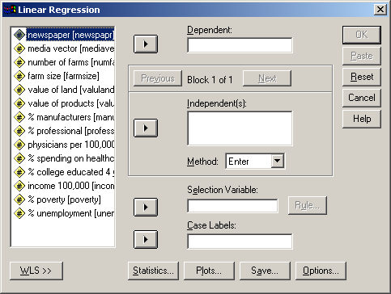

- Media Vector will be the Dependent Variable.
- All other characteristics except newspaper will be Independent Variables.
- Change Method to Stepwise.
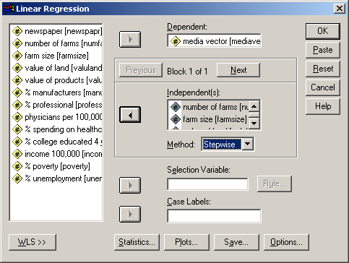

- Click on Statistics
- Check the following boxes: Estimates, Confidence Intervals, Covariance Matrix, Model fit, R squared change, and Descriptives, then hit Continue.
- Click on Save.
- Click on all boxes under Predicted Values then hit continue.
- Click on Options.
- Change Entry to .40 and Removal to .45 then hit Continue.

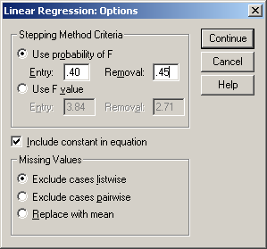

13. Finally, hit OK on the Linear Regression window.

Your output will be large but you will look to the Model Summary for your results.

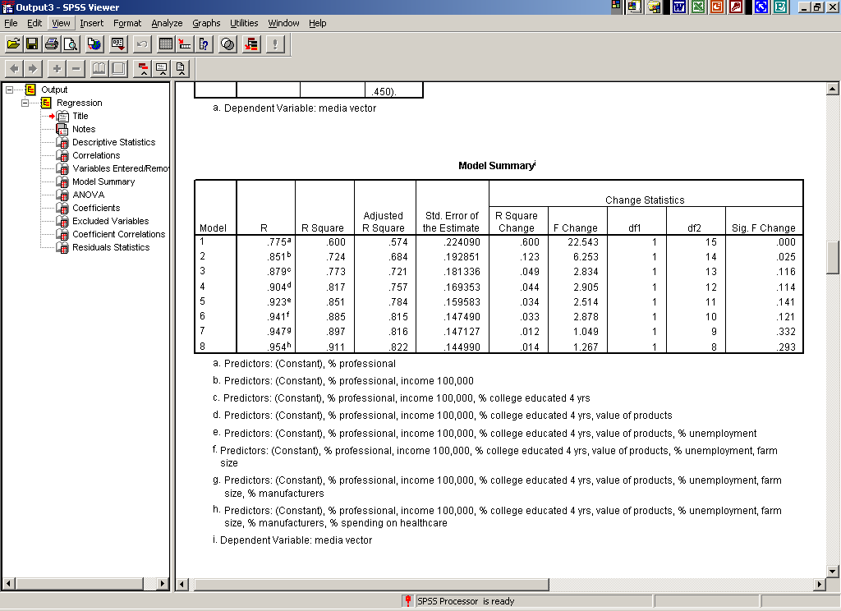
Sample output.

It is possible to have no significant results.

