Exam

Name:

Identify each of the following variables as either qualitative or quantitative.

- A monthly electric bill (in dollars).
A) Quantitative B) Qualitative

- Outcome of tossing a coin.
A) Quantitative B) Qualitative

Classify the data as either discrete or continuous.

- The average height of all freshmen entering college in a certain year is 68.4 inches.

A) Discrete B) Continuous

- The following table shows the heights of the five tallest mountains in North America.

Mountain | Height (ft) | Rank
McKinley | 20,320 | 1
Logan | 19,850 | 2
Citlaltepec | 18,700 | 3
St. Elias | 18,008 | 4
Popocatepetl | 17,930 | 5

What kind of data is given in the third column of the table? The rank is ordinal data.

A nurse measured the blood pressure of each person who visited her clinic. Following is a relative-frequency histogram for the systolic blood pressure readings for those people aged between 25 and 40. Use the histogram to answer the questions. The blood pressure readings were given to the nearest whole number.

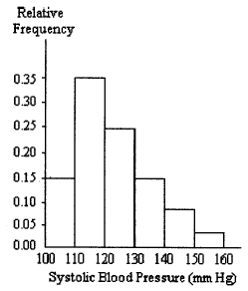

- Approximately what percentage of the people aged 25-50 had a systolic blood pressure reading less than 150?

95% of people aged 25-40 had a systolic blood pressure reading less that 150.

- Find the median systolic blood pressure.

The median systolic blood pressure is 120-130 mmHG.

- Do you think the mean would be higher or lower and why?

The mean would be lower because the distribution is skewed to the right, which shows that there is a higher concentration of lower values.

- Describe the shape of the distribution.

The distribution is unimodal and right-skewed with no outliers or gaps.

Provide an appropriate response.

- Explain the difference between a frequency distribution and a relative frequency distribution. Comment on the differences on the vertical axis scale. Given the same data set and the same classes, will the shapes of the frequency distribution and the relative frequency distribution the same? You may draw a diagram to support your answer.

A frequency distribution shows the number of cases in each category, while a relative frequency distribution shows the percentage of values in each category.
Given the same data and classes, the distributions would be the same.

- Explain in your own words the difference between a bar graph and a histogram. Give an example of data for which you might use a histogram and an example of data for which you might use a bar graph.

Bar charts show the frequency of a categorical value, obey the area principle, and are often spaced apart, whereas histograms show the distribution of quantitative data with varying heights and have no insignificant gaps. Histograms also follow the area principle. One might use a bar chart to show the number of each brand of car bought in a year while a histogram could be used to display the number of cars bought in one year in each price range.

Construct a stem-and-leaf diagram for the given data.

- The following data show the number of laps run by each participant in a marathon.

46 65 55 43 51 48 57 30 43 49 32 56

3  4  5  6 | 0 2  3 3 6 8 9  1 5 6 7  5

Provide an appropriate response.

- The bar graph shows the number of car accidents occurring in one city in each of the years 1993 through 1998. The number of accidents dropped in 1995 after a new speed limit was imposed. Why is the graph misleading? How would you redesign the graph to be less misleading?

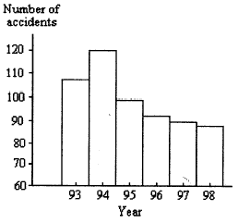

The chart is misleading because the number of accidents does not start at zero, and, consequently, the bins do not follow the area principal and suggest that there is a greater variance between the years than there really is. To correct this, the numbers on the y-axis should begin with 0 instead of 60.

Find the mean for the given sample data. Unless otherwise specified, round your answer to one more decimal place than those used for the observations.

- Last year, nine employees of an electronics company retired. Their ages at retirement are listed below. Find the mean, median, and midrange of their retirement ages.

- 60 65
- 64 58
- 53 50

The mean age is 57.7, the median is 58, and the midrange is 57.5.

Provide an appropriate response.

- The two most frequently used measures of central tendency are the mean and the median. Compare these two measures for the following characteristics: Takes every score into account? Affected by extreme scores? Advantages.

The median is more resistant to change, so if there is an extreme outlier it will not affect the measurement of center, whereas the mean would be drastically affected by such values. However, the median covers up very large or small values in the data, so it would not represent any significant statistical anomalies, while the mean takes every value into account.

- Suppose that a data set has a left-skewed distribution. Which do you think will be larger, the mean or the median? Explain your thinking.

The mean would be higher because there would be a higher concentration of larger values in a left-skewed distribution. However, if there were a significant number of extremely smaller values or outliers in the distribution, they would affect the mean and the median would most likely be higher.

Provide an appropriate response.

- We want to compare two different groups of students, students taking Composition 1 in a traditional lecture format and students taking Composition 1 in a distance learning format. We know that the mean score on the research paper is 85 for both groups. What additional information would be provided by knowing the standard deviation?

The standard deviation would indicate the spread by showing the variance from the mean. The smaller the standard deviation, the closer the scores would be to 85, whereas the larger the standard deviation the more varied the scores and, we can assume, the level of skill of the students.

- The range and standard deviation of the data set below are 35 and 12.47 respectively.

5, 24, 25, 26, 40

If the 26 is replaced with 39, how will this affect the range? How will this affect the standard deviation? Use your answers to explain why the standard deviation is preferable to the range as a measure of variation.

If 26 is replaced with 39, the range would not be affected, whereas the standard deviation would be larger. This shows that standard deviation is preferable to the range for measuring variation because it takes all scores into account and adequately displays the amount of deviance from the median.

Obtain the five-number summary for the given data.

- The National Education Association collects data on the number of years teaching experience of high-school teachers. A sample taken this year of 19 high-school teachers yielded the following data on number of years teaching experience. Find the IQR.

33 13 1 21 31
8 3 11 2 23
25 1 33 28 4
17 24 22 31
For this data set, the minimum is 1, Q₁ equals 4, the median is 21, Q₃ equals 28, and the maximum is 33. The interquartile range is 24.

- Give an example of a data set where the mean is larger than the median. 1, 2, 3, 4, 107
- Mean is smaller than the median. 1, 36, 37, 38, 39
- Median is larger than the midrange. 10, 11, 12, 13, 14

- What would be a quick way to calculate the mean of 621, 623, 624, 624, 625, 627 in your head?

Since both 621 and 627 are 3 away from 624, the median, and since both 623 and 625 are 1 away from the median, in opposite directions, these values “cancel each other out” and leave us with 624, which is the mean.

Fill in the blanks by standardizing the normally distributed variable.

- Dave drives to work each morning at about the same time. His commute time is normally distributed with a mean of 42 minutes and a standard deviation of 5 minutes. Fill in the following blanks.

The percentage of time that his commute time exceeds 57 minutes is equal to the area under the standard normal curve that lies to the right of 3.

- The amount of time that customers wait in line during peak hours at one bank is normally distributed with a mean of 12 minutes and a standard deviation of 4 minutes. Fill in the following blanks.

The percentage of time that the waiting time is less than 11 minutes is equal to the area under the standard normal curve that lies to the left of -.25.

Provide an appropriate response.

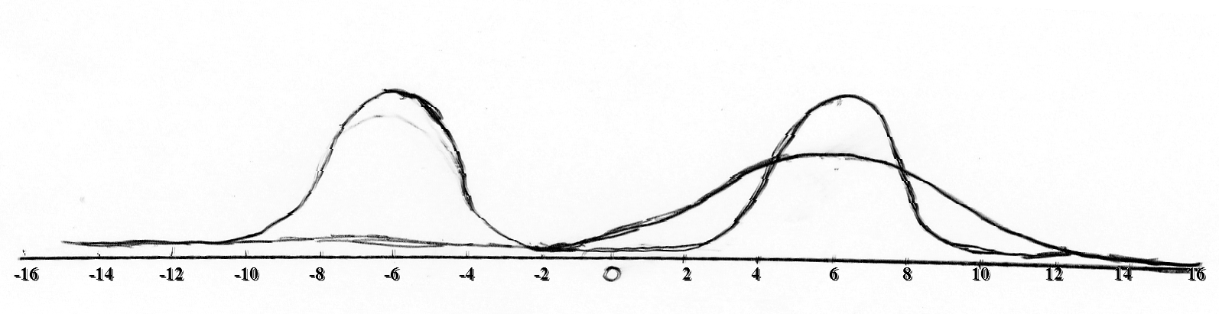
- On the same axes sketch normal distributions with

  - μ = 6, σ = 4
  - μ = 6, σ = 2
  - μ = -6, σ = 2

- Which is larger, the area under the standard normal curve between -1 and 1, or the area under the standard normal curve between 0 and 2? Explain your reasoning.

Knowing the characteristics of a standard normal curve, we can determine that the area between -1 and 1 would be greater than that between 0 and 2. This is because we know that 68.3% of the area lies between -1 and 1 and 95.4% lies between -2 and 2 in a standard normal curve. If we divide 95.4 by two, since we are only measuring the area between 0 and 2 (half of the area between -2 and 2), we find that 47.7% of the area lies between 0 and 2, a value which is less than the 68.3% between -1 and 1.

Use the table of areas to find the specified area under the standard normal curve.

- Find the area under the standard normal curve that lies to the left of 1.13.

The area under the standard normal curve that lies to the left of 1.13 is 0.8708.

Provide an appropriate response.

- Suppose that you know the area under the standard normal curve to the right of 2 and the area under the standard normal curve to the right of 1. Without further consulting a table of areas, how could you find the area under the standard normal curve between 1 and 2? Explain your reasoning.

To find the area between one and two, you could subtract the value of the area to the right of two from the area to the right of one. That way, the excess would be trimmed away and the value that would remain would be just the area between the two z-scores.

- Suppose that you know the area under the standard normal curve between 1 and 3 and that area under the standard normal curve to the left of 3. Without further consulting a table of areas, how could you find the area under the standard normal curve to the left of 1? Explain your reasoning by using a sketch of the standard normal curve.

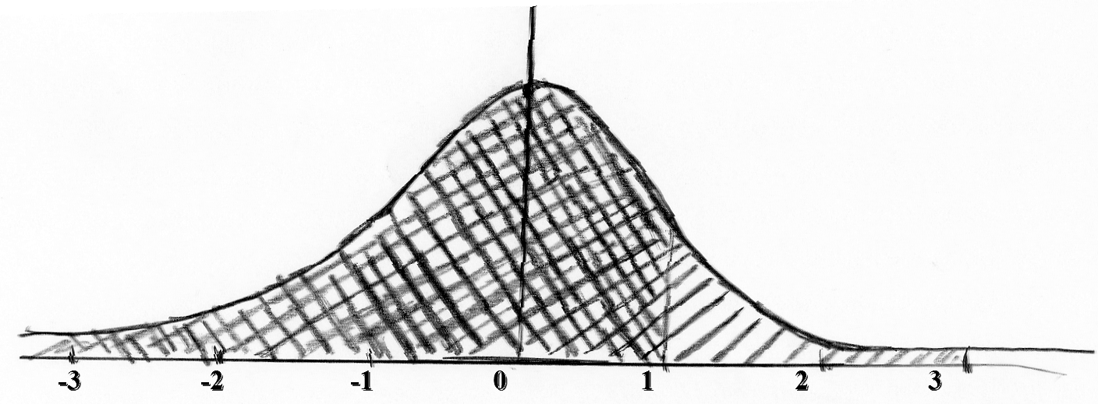

To get the area to the left of one, you would subtract the area between one and three from the area to the left of three. This would reduce the measured area from the entire shaded region to the darker region in the graph above, which is the area to the left of one.

- A variable is normally distributed with a mean of 100 and a standard deviation of 10. A student wanted to find the percentage of observations of the variable lying between 106 and 110. What is wrong with his solution?

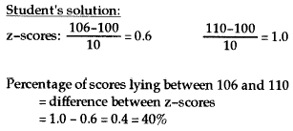

The student’s solution is incorrect because he found the difference between the z-scores and not their corresponding areas. Without using the area measurements for the distribution, the student did not find the percentage of the observations for the variable between 106 and 110.

Construct a boxplot or a modified boxplot as specified.

- The test scores of 40 students are listed below. Construct a boxplot for the data set.

- 35 43 44 47 48 54 55 56 57
- 62 63 65 66 68 69 69 71 72
- 73 74 76 77 77 78 79 80 81
- 82 83 85 89 92 93 94 97 98

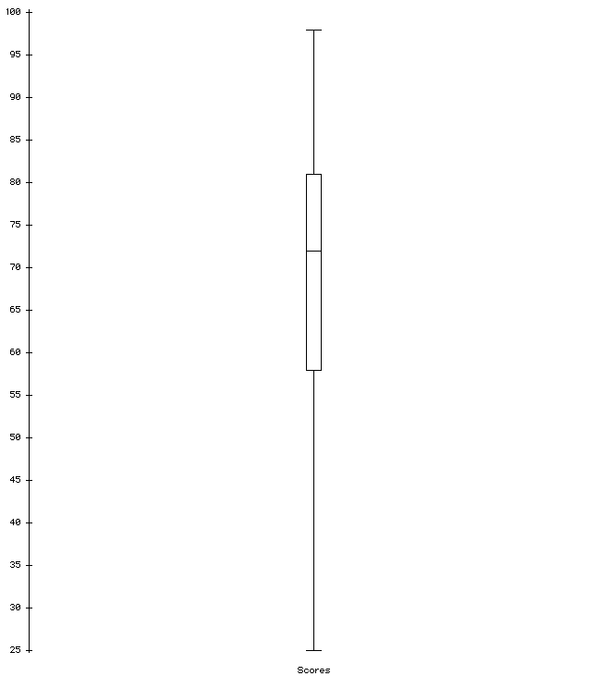

Answer true or false for all of the following questions. Say false if you can’t know for sure.

At least 25% of the students scored above 80.
True
More than 75% of the students scored at least 60.
False
Half of the students scored between 57 and 81 points.
False
At least 255 of the students scored below 55.
False

- Create a histogram with bin sizes: 0-5, 5-10, 10-20, 20-35, 35-40 where the respective percentages of the data in each bin are equal to: 10%, 15%, 10%, 45%, 20%.
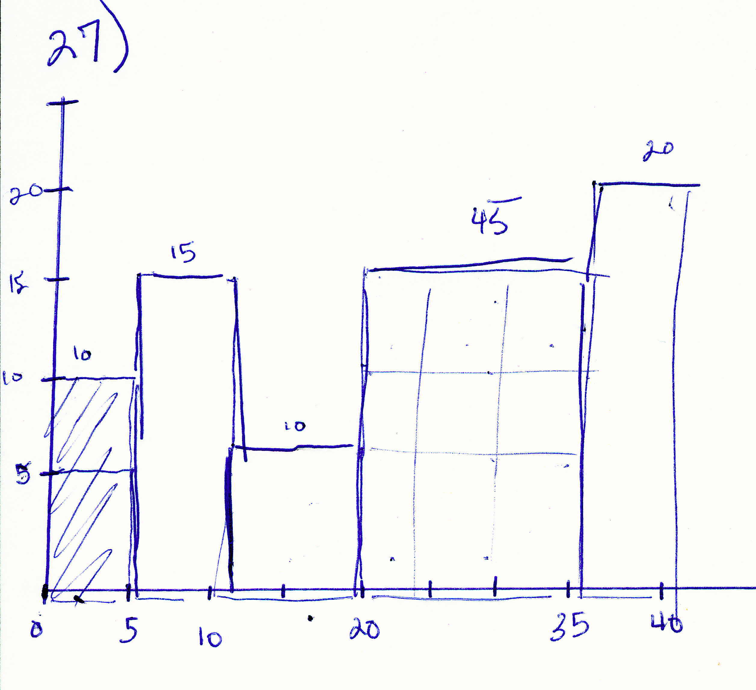

- DISCUSS with your group: What are the main concepts in this course so far that you are feeling the least secure of using? What would you like to have more discussion about at the review session? Specific questions?

As a group, we determined that we are least comfortable with calculating and using the standard deviation. IQR measurement is also confusing. For a review session, we would like to discuss all concepts from the beginning of the semester.

- The histogram below shows the amount of U.S. commitment to selected Latin American countries in 1993 and 1999. The Aid histogram is the 1993 data, the Later histogram is 1999 and the Aid-Ltr histogram displays the differences of the respected values from 1993 to 1999. Did the amount of U.S. assistance increase or decrease over this period overall? For how many countries did the U.S. increase/decrease assistance?
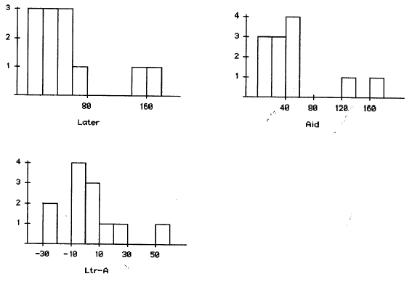

Overall, the U.S. increased assistance in Latin America between 1993 and 1999. It increased assistance to six countries and decreased assistance to six countries.

